Reporting Time (punch time) - Timesheet

Reporting the number of hours you worked is done in HCM>Employee Self Service>Time tile.

Navigation: Employee Self Service (homepage) > Time (tile/homepage) > Enter Time (tile)
- Select the Time Tile.
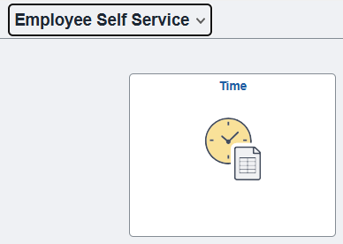
- The Time homepage displays.
- Select the Enter Time tile.
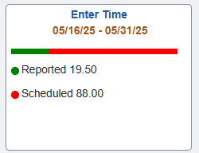
- The Enter Time page displays.
- At the top of the page, the system displays the Employee Record Number, Hourly Rate and Supervisor Name for the job record.
If the employee has more than one active job, a link displays under the employee name and job description. To report time in another job, click the Select Another Job link and select the appropriate job from the Change Job Selection window. The system displays the updated Record Number, Hourly Rate and Supervisor Name.
- Click the Calendar icon to select the start date of the time reporting period or start of a week within the period.
- The View By field offers a drop-down menu with two calendar options: Period and Weekly to view the time-sheet based on the selected calendar view option.
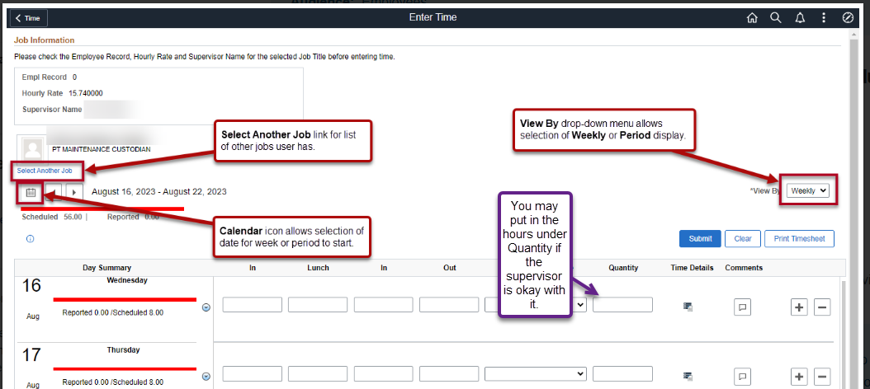
- Select the Time Reporting Code (TRC) from the drop-down on the right.
- Enter the following:
  - In: time that the employee started work for the day.
  - Lunch: time that the employee left for their meal.
  - In (from Lunch): time that the employee returned to work.
  - Out: time that the employee finished work for the day.
- If no meal is taken, enter the following:
  - In: time the employee started work for the day.
  - Out: time the employee finished work for the day.
- Time is assumed to be 24hr time if no AM or PM entry is indicated.
  - For example, 8:00 AM can be entered as either 8 or 8AM in the timesheet.
  - For example, 2:00 PM can be entered as either 14 or 2PM in the timesheet (i.e. if 2 is entered without the PM then the system will assume that means 2 AM).
- Select Submit.
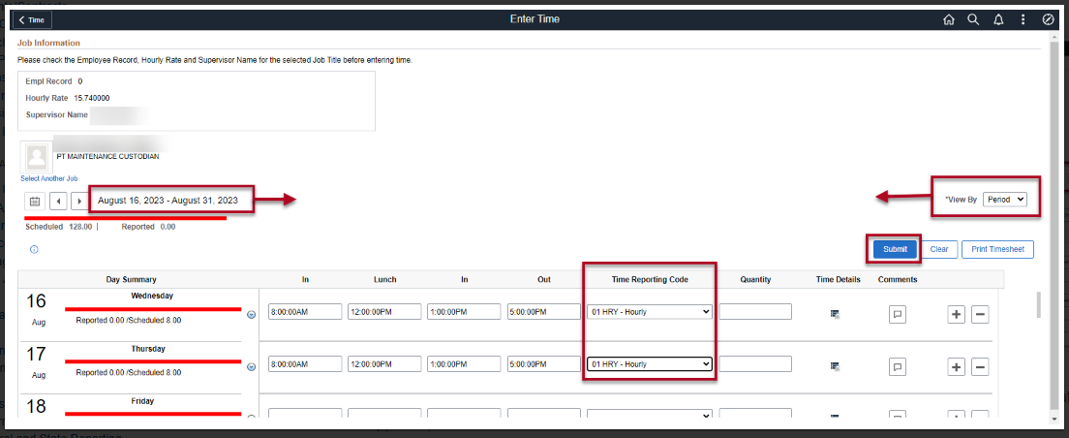
- Time will be processed periodically and sent to the employee’s manager for approval (if it is a TRC that needs approval).
- If an additional TRC was worked in that day:
  - Select the (+) on the right-hand side of the screen to add a row.
  - Select the new TRC from the drop-down menu on the right.
  - Enter the hours worked on the new TRC.
  - Select Submit and OK.
- If time needs to be changed:
  - Enter a new hour range on the day that needs to be altered.
  - Select Submit and OK.
- If a TRC needs to be removed from the timesheet:
  - Select the (-) on the right-hand side of the screen to remove a row from the day.
  - The system will prompt a question, select either Yes Delete or No Do Not Delete.
  - If Yes Delete was chosen and the employee wishes to finalize their choice, select Submit and OK.
- If a Comment is needed select the comment box below the day in which a comment is needed, type in text, and select Add Comment.
  - Comments, once entered, cannot be altered or removed. Additionally, all comments recorded by employees are considered discoverable.
NOTE: Time is processed periodically, but at minimum overnight. Time entered may not be visible to the employee or manager in other screens until the overnight processing has occurred.
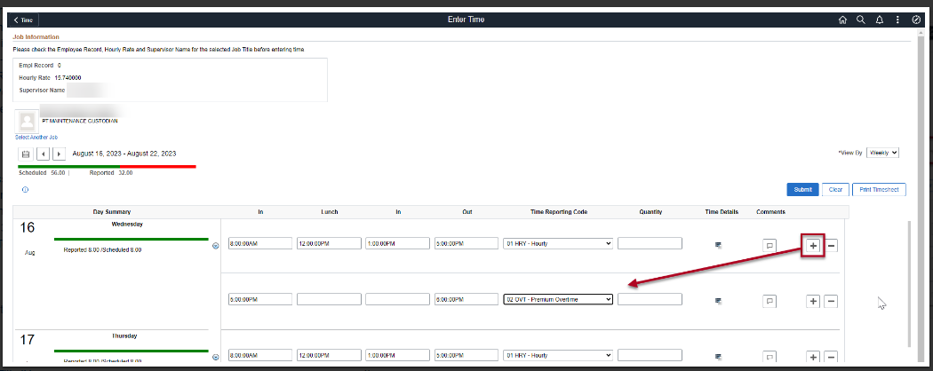

End of procedure.

Important Things to Note
Timesheets are due by 9 a.m. the day after the 15th and the day after the last day of the month.
Pay days are normally on the 10th and the 25th

That’s it!

